Name :Sk.Kashifa
Register no : Food ordering system

Class diagram :

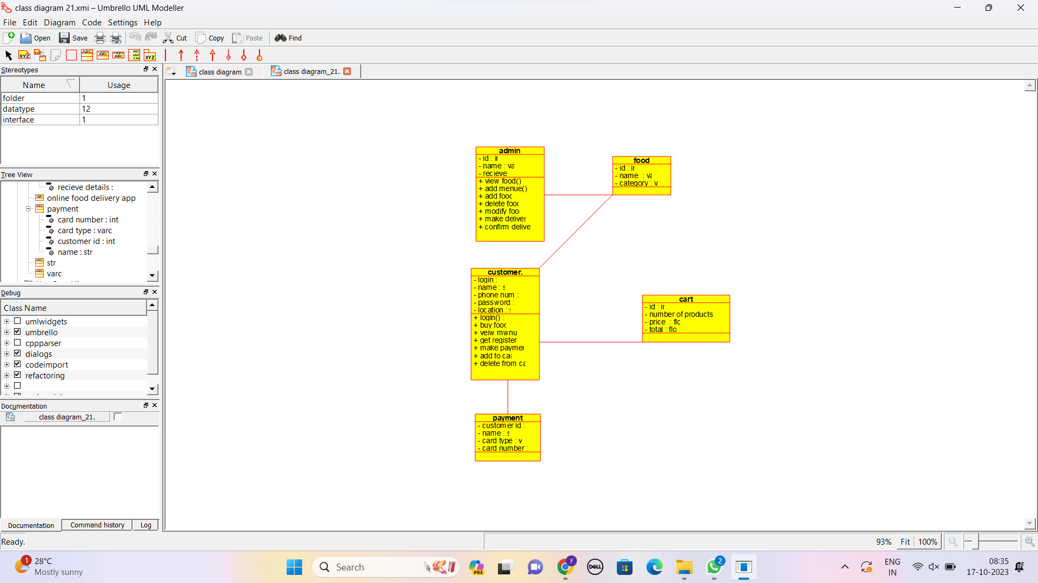

Usecase diagram :

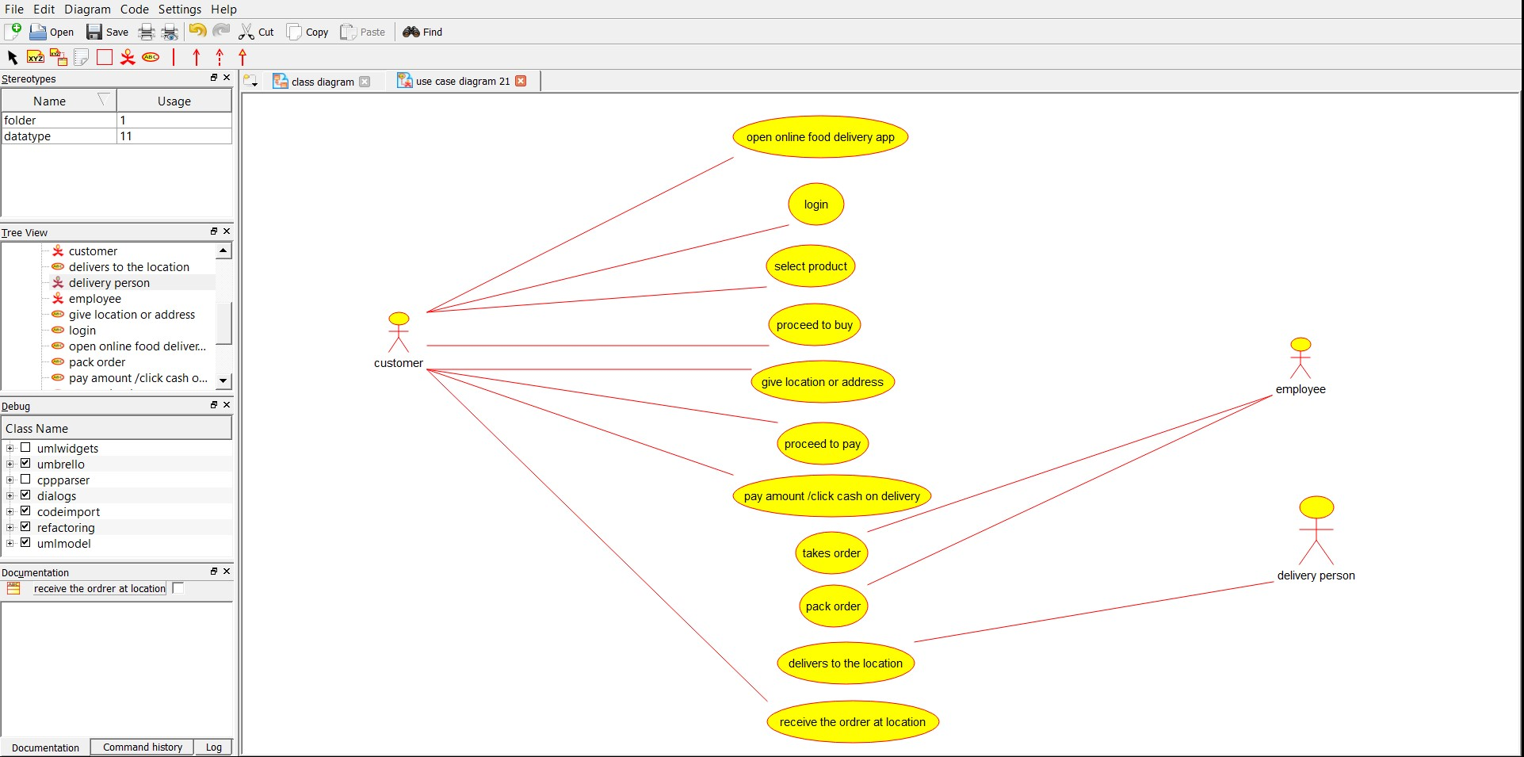

Deployment Diagram :

